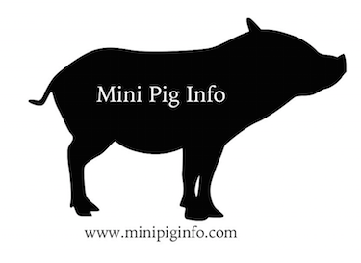

- All pigs grow bigger. There is no such a thing as a teacup or micro pig. These are simply terms people use to entice you to buy a pig from them.

- No one can guarantee the size of your pig when your pig hits maturity somewhere between 3-5 years old. If someone is claiming a weight guarantee…run.

- “Mini” pig is not a breed of pigs; this word is used to distinguish a smaller breed of pig from a farm pig and is often used interchangeably with potbellied pig. Most “mini” pigs weigh somewhere between 60-200lbs.

- Intact pigs do NOT make good pets. Intact male pigs tend to have a noxious odor when not neutered, both sexes will constantly look for a mate and will leave undesirable signs to let another potential pig know they’re there. Intact pigs also tend to have behavioral issues.

- Piglets NEED to spend an appropriate amount of time with their mother. 6-8 weeks at the very least. Bottle-feeding a pig will NOT bond you and your pig, but can lead to your piglets untimely death due to aspiration pneumonia.

- Some people will try to pass off a pig as much older than a piglet actually is. This is a way to “show” you how small their pigs are, this is a dangerous practice and has claimed the lives of many pigs by being taken from their mother too soon.

- Pigs need regular vet care; vaccinations and hoof care at minimum.

- Pigs NEED time outdoors. Pigs need space to root and dig and play. Without this opportunity, many pigs have been known to become destructive inside the house. Giving them the time and space outside can prevent undesirable behaviors indoors.

- Healthy pigs can live 20 years or longer. Pigs are a lifetime commitment.

- Pigs grieve the loss of their families; you never want to see a pig cry real tears.

- In most areas, you must be zoned to have a pet pig. Some cities have specific ordinances while others do not address it at all. You MUST know your city’s stance and have something in writing or they may come take your pig away from you. HOA (homeowners association’s) also need to be investigated for clauses about pigs.

- Pigs do better in pairs. It is possible to have 1 happy pig, but they do better with a friend. Pigs need a “herd”. If there is not a second pig, you and your family are part of the herd and will need to work on training your pig to know who the leader of the herd is. (It should NOT be the pig)

- Pigs do NOT do well with dogs because they are natural enemies. Many family dogs have killed or severely injured the family pig. NEVER leave them alone unsupervised.

